2019

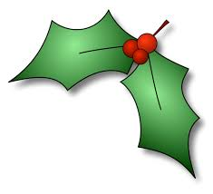

Holiday Schedule

So that our employees have the opportunity to celebrate the season with family and friends, the Freeport Park District will observe the following 2019 holiday schedule.

Wednesday, November 27 8-2 pm
Thursday, November 28 (Thanksgiving) CLOSED
Friday, November 29 CLOSED

Tuesday, December 24 (Christmas Eve) CLOSED
Wednesday, December 25 (Christmas Day) CLOSED
Tuesday, December 31 (New Year’s Eve) 8-2 pm
Wednesday, January 1, 2020 (New Year’s Day) CLOSED

Happy Holidays from the Freeport Park District

